Collagen hybridization
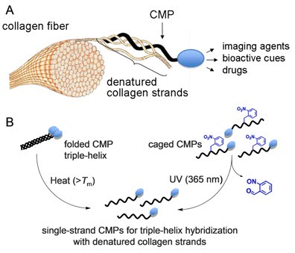
Collagen is the fundamental extracellular matrix scaffold that supports cell proliferation, differentiation, and regeneration. It plays a crucial role in tissue development and renewal, and its structural or remodeling abnormalities are associated with various debilitating diseases and pathological conditions (e.g., cancer, osteoporosis, arthritis, fibrosis, etc). In addition, collagen-based biomaterials wide used in regenerative medicine such as tissue engineering are often partially denatured by the material fabrication and preparation processes. Therefore, the ability to target disrupted collagen strands could lead to new diagnostics and therapeutics, as well as applications in tissue engineering and regenerative medicine. We discovered that single-strand synthetic collagen mimetic peptides (CMPs) can specifically bind to collagens denatured by heat, chemicals or by natural enzymatic remodeling activities, through a unique triple-helix hybridization mechanism (A). We have developed both physical and chemical strategies to deliver these CMPs in single strands to achieve effective collagen targeting (B). This new hybridization technology enables a wide spectrum of biomedical applications, such as diagnostic imaging, targeted and controlled drug delivery, and novel biomaterials for tissue engineering and regenerative medicine.

Targeting collagen remodeling in pathological tissues
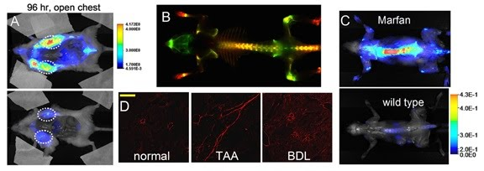
By conjugating a imaging modality (e.g., a near infrared fluorophore) onto the CMP, we are able to show that the CMP can target collagen remodeling activity both in vivo and ex vivo. (A) Near infrared fluorescence (NIRF) images of mice bearing prostate tumors administered with UV-triggerd caged CMPs or sequence-scrambled control peptide, indicating tumor specific and stable accumulation of only the CMP (top) and not the control peptide (bottom). (B) Views of a mouse skeleton showing the overall uptake of CMP (red) in both bones and cartilages compared to BoneTagTM(targeting calcifying bones, green). (C) NIRF images of a mouse model with Marfan syndrome after CMP administration showing elevated CMP uptake in the skeleton of the diseased mouse. (D) Fluorescent micrographs of normal and fibrotic rat liver sections (TAA and BDL) stained by fluorescent CMPs (red), displaying distinct collagen distributions in different liver models (scale bar: 200 μm).
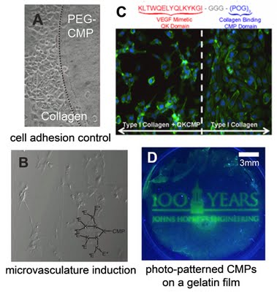

Functionalization of collagen scaffolds
We have developed various CMP derivatives to functionalize collagen matrix and control cellular behaviors. PEG-CMP prevents the cell adhesion on collagen substrates (A), whereas anionically charged CMP can bind to collagen matrix and signal endothelial cells activation by attracting vascular endothelial cell growth factor (VEGF) in a 3D collagen gel (B). A pro-angiogenic peptide is conjugated to the CMP resulting in a novel CMP with both collagen binding and angiogenic capacities. Local controlling of peptide immobilization leads to induced cell morphogenesis in pre-defined areas within cell culture (C). The ability to encode spatially defined biochemical signals on collagen/gelatin scaffolds (D) is expected to provide new pathways for engineering complex tissues for regenerative medicine.

PEG-CMP hydrogels
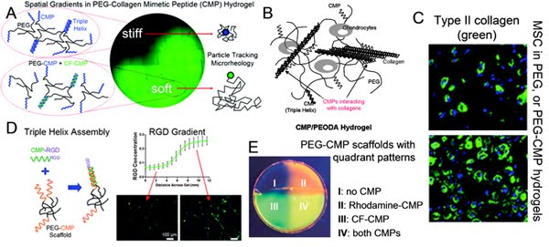
We have also been working on synthetic PEG-based hydrogels thatfeature CMP chains not only as non-covalent cross-links but also as sites for scaffold functionalization. We demonstrate that multi-arm PEGconjugated with CMPs form hydrogels through physical cross-links mediated by the CMP triple helices. The disruption of these physical cross-links enables the modulation of bulk hydrogel elasticity and the introduction of local stiffness gradients in PEG-CMP hydrogels (A). We are also working with photopolymerized PEG diacrylate (PEGDA) hydrogels displaying CMPs which can retain cell secreted collagens and promote maintenance of chondrocytes (B), as well asdirect the differentiation of stem cells into the chondrogenic pathway (C). Such PEG-CMP hydrogels can also be further conjugated to CMPs with bioactive moieties via triple helix hybridization (D). Encoding these hydrogels with bioactive CMPs induces cell spreading, proliferation, or activation. We further demonstrate generation of patterns of cell-instructive cues across the PEGDA scaffold that mimic the distribution of insoluble bioactive factors in the natural ECM (E).

